Assignment – 05:
Create a public bucket in AWS. Upload a file and give necessary permission to check whether the file URL is working.

Steps:
- Search for s3 and click on Buckets feature under S3 service.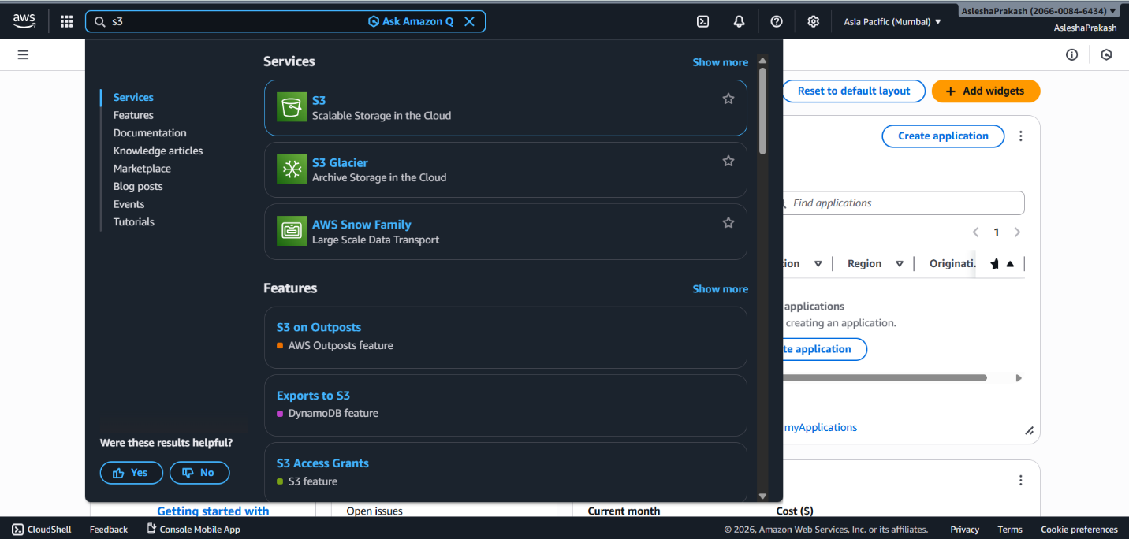

- Click the Create bucket button appearing on top right of General purpose bucket section.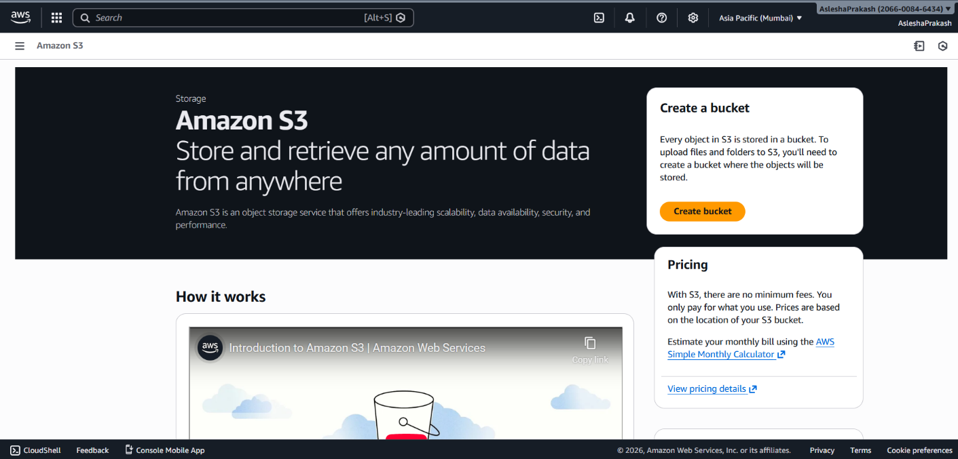

- Add a bucket name. Make sure the region is as per the final choice since it cannot be changed once created.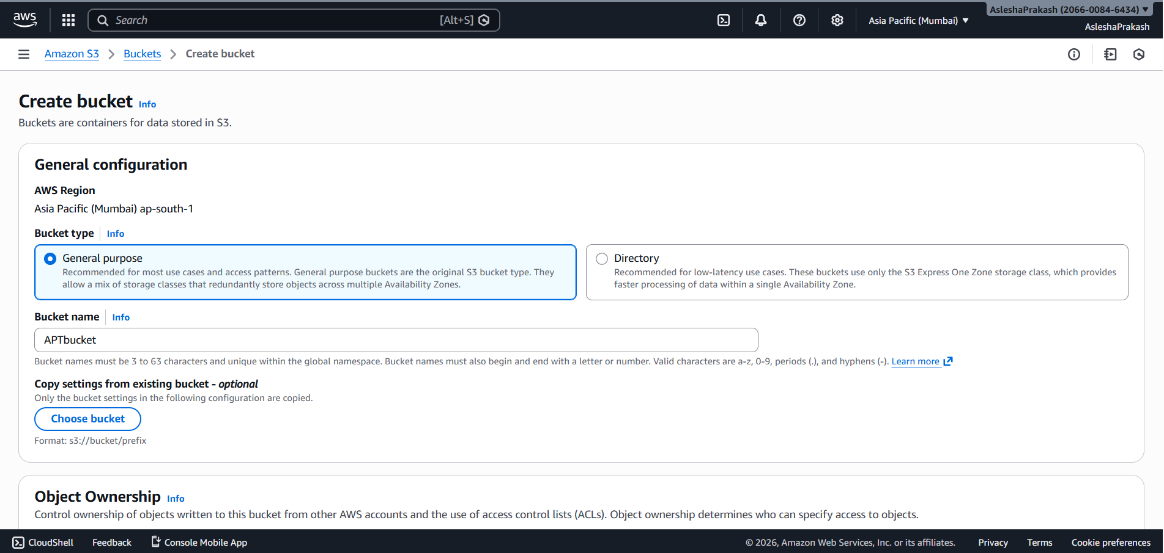

- Under Object Ownership section select ACLs enabled and check Bucket owner preferred as Object ownership.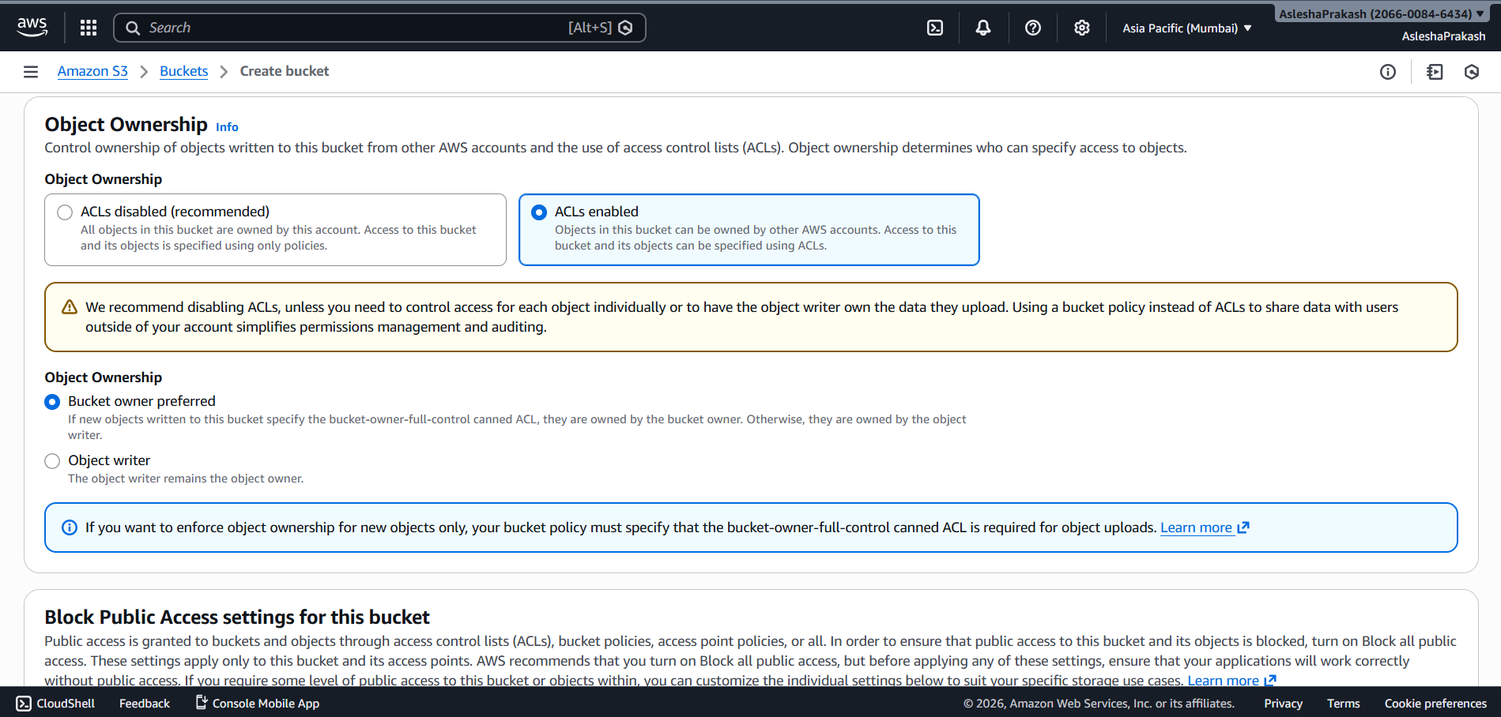

- Make sure the “Block all public access” option is checked to create a private bucket.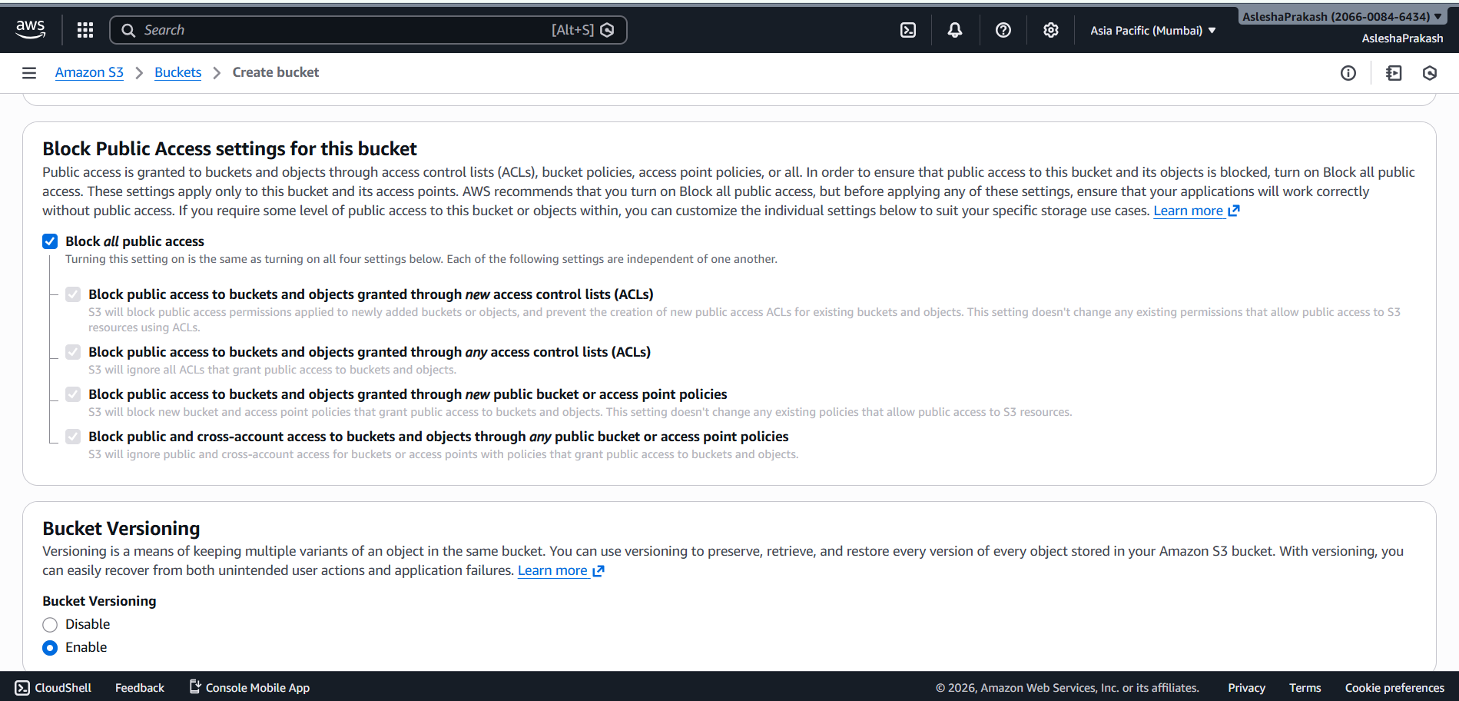

- Under Default encryption section, keep the default selections (SSE-S3 and bucket key enabled) and then click on Create bucket button. 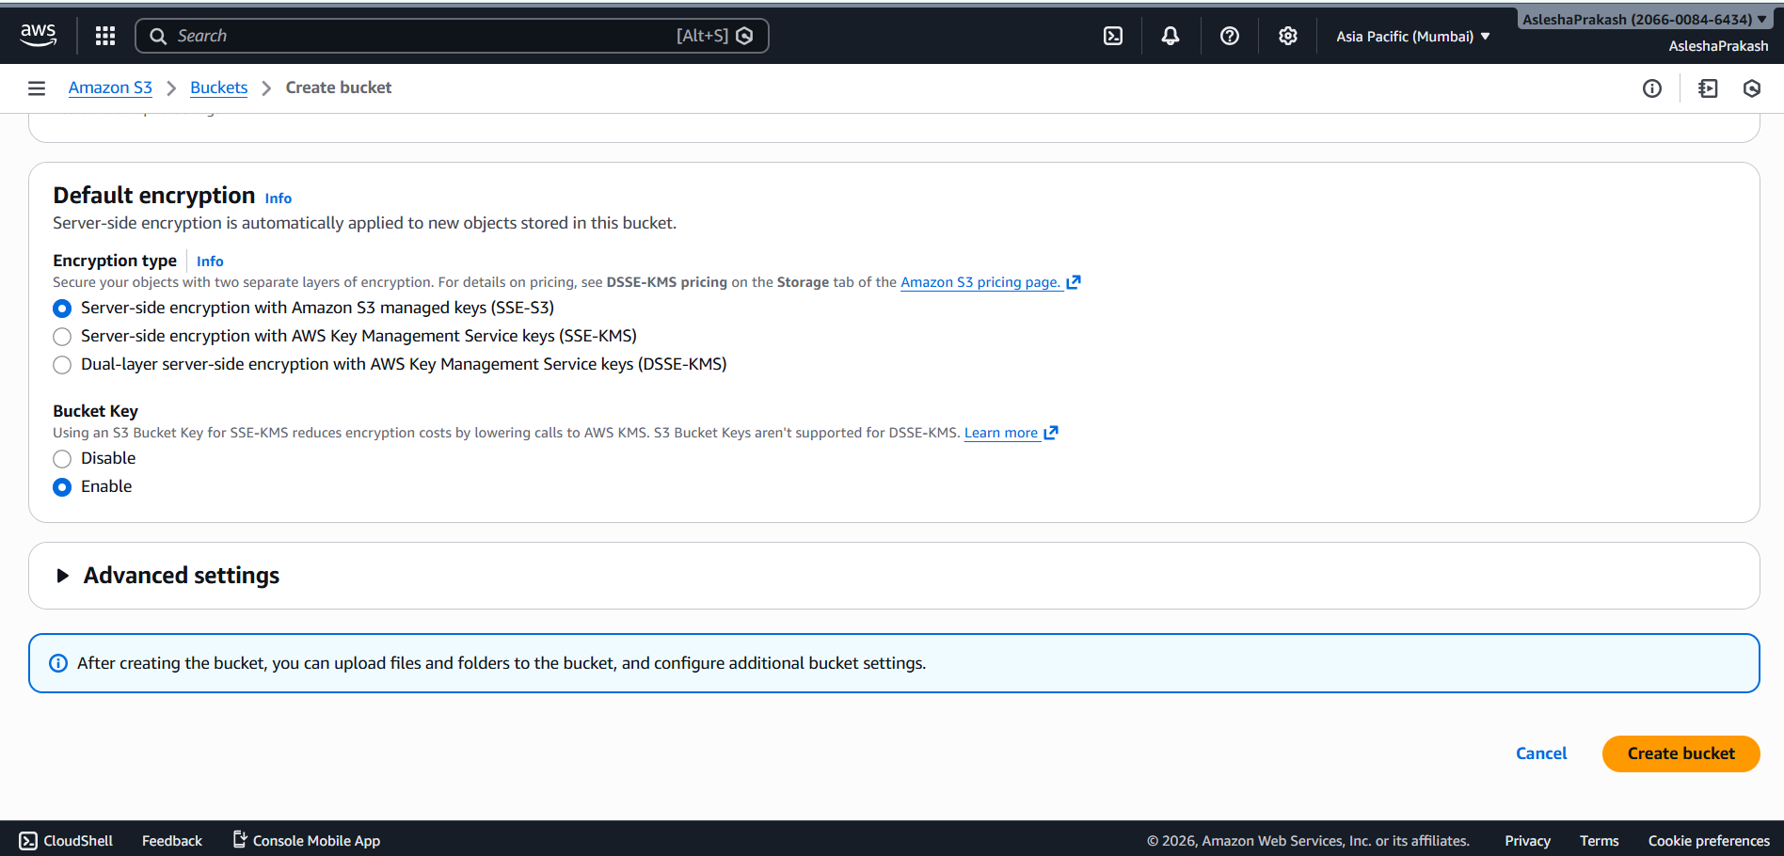

- A green confirmation ribbon will appear on successful creation of the bucket. Furthermore, click on the new bucket just created.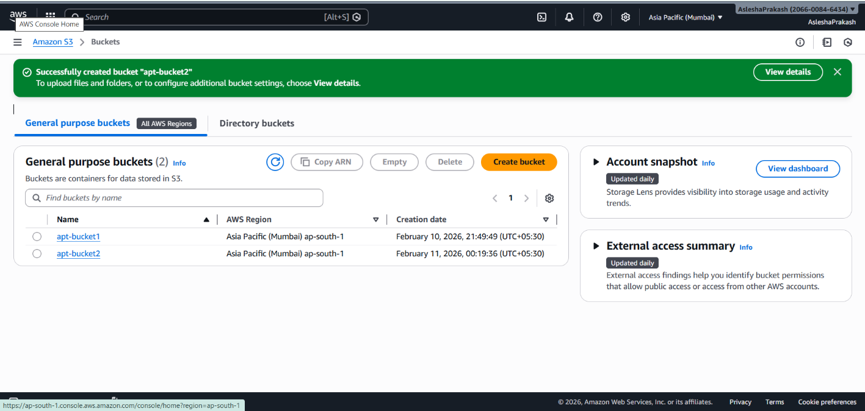

- To upload a media, click on Upload button.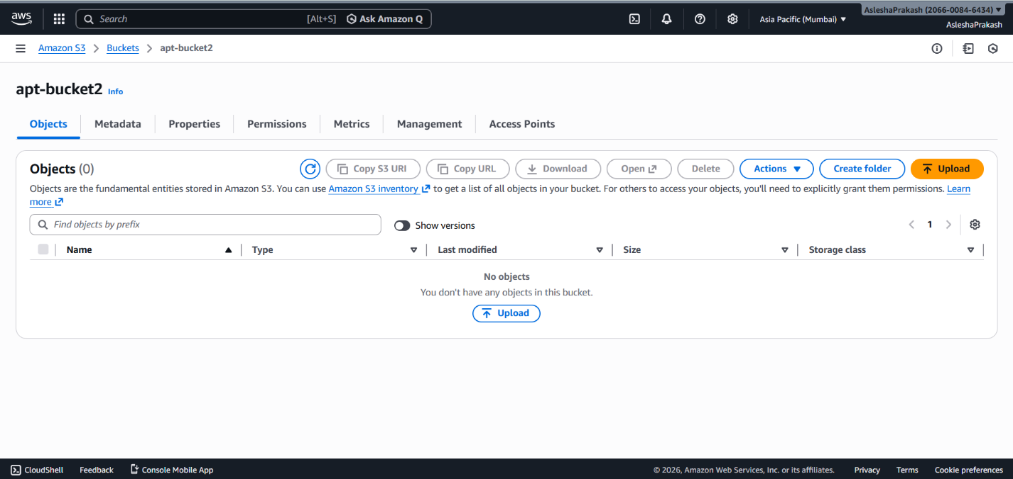

- Click on Add file/folder to upload any kind of files/folders. Once the desired files/folders are uploaded they will be listed. On successful listing, click on Upload button.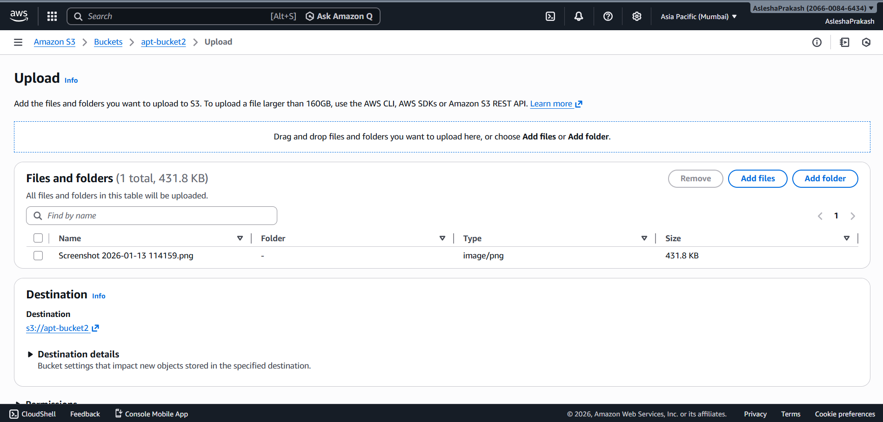

- A green confirmation ribbon will appear marking successful upload. Click on Close to return to the bucket and then click on uploaded file name to view details of it. 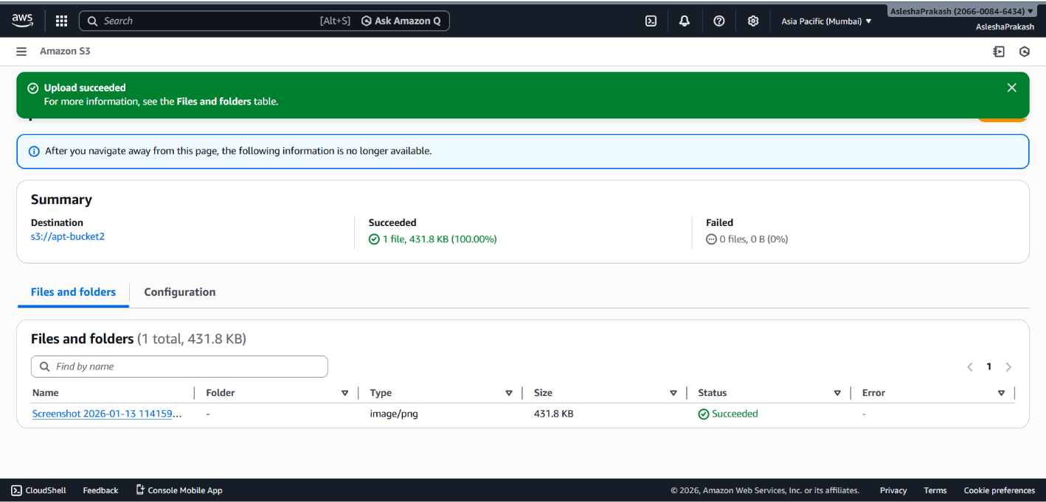

- Copy the object URL and paste it in incognito tab to view the file just uploaded. Since it was uploaded in a private bucket, we cannot see the contents.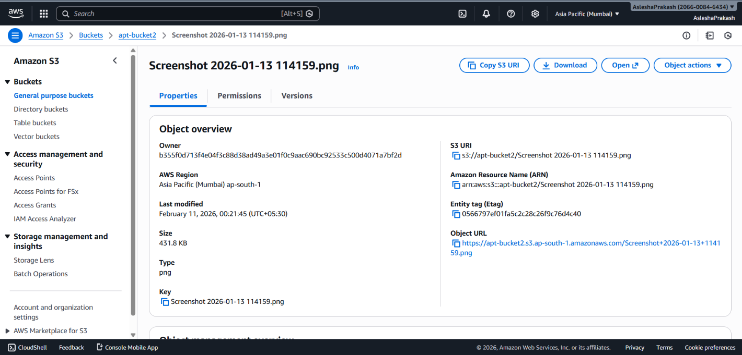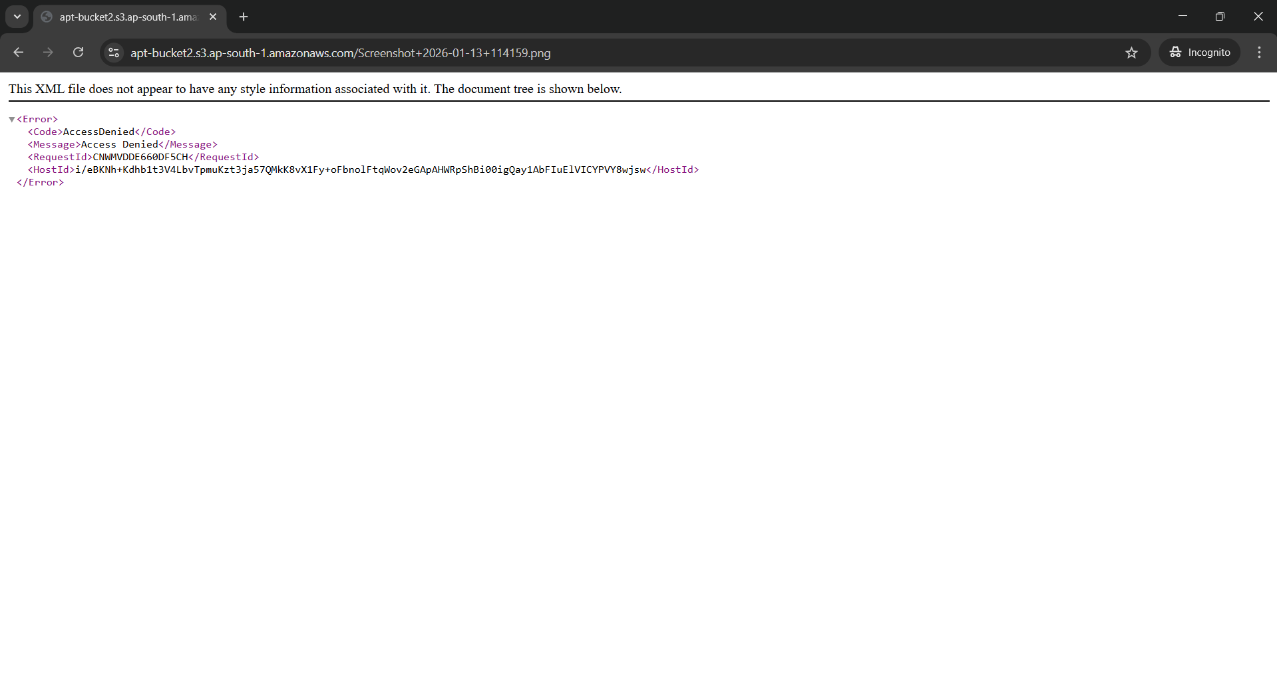

- Go back to the file details page and click on Object actions dropdown. Then select Share with a preassigned URL.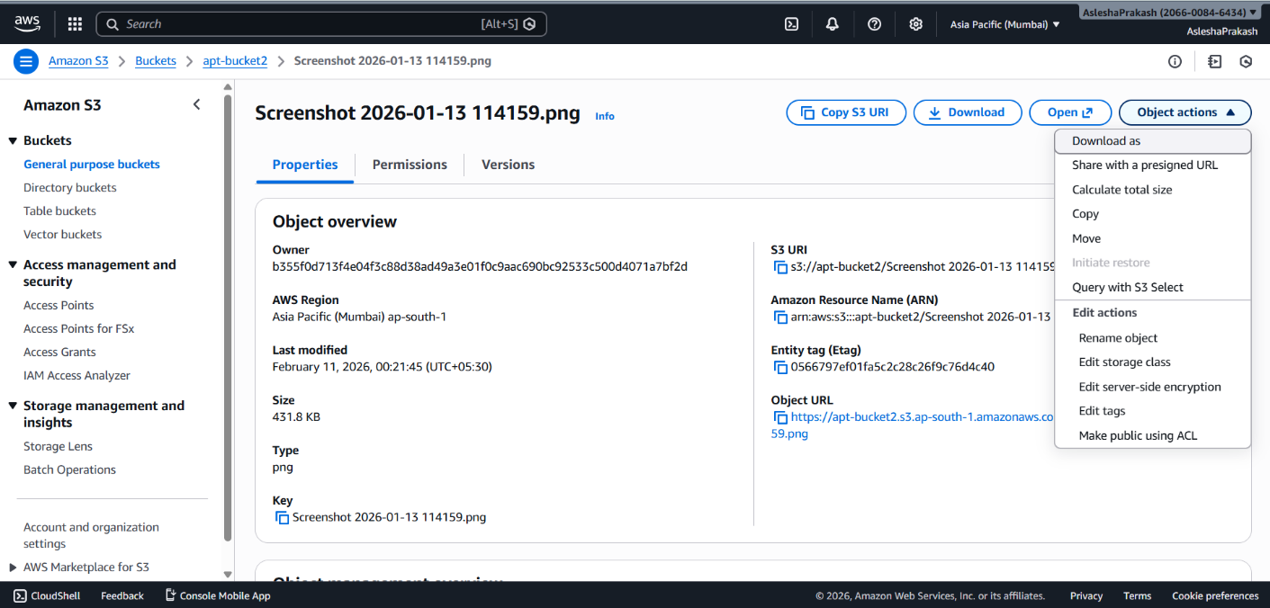

- Select Minutes for time interval and then set the timer to 2 minutes and click on Create preassigned URL button.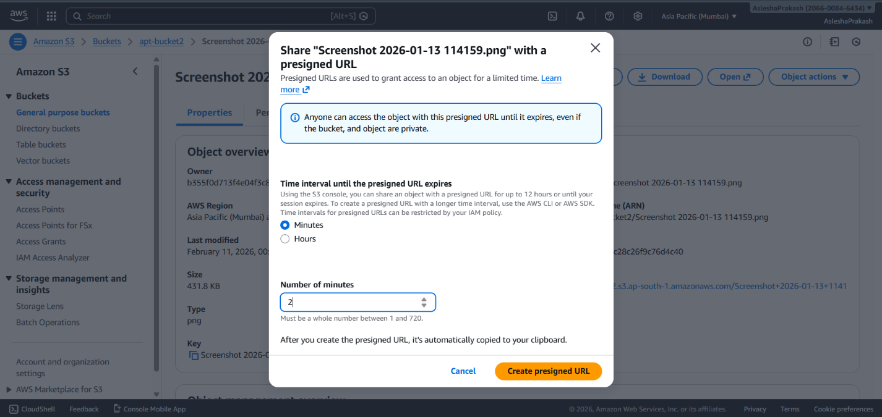

- A confirmation banner will appear. Click on the Copy preassigned URL button appearing in it and paste it in Incognito mode again. This time the file will open.